**“EVALUATION OF ACADEMIC PERFORMANCE OF STUDENTS WITH FUZZY LOGIC”**

**Ganesh S.Misal 1, Shradha V.Saraf 2 , Suraj W.Koli3 , Maheshwari B.Patil 4**

**1,2,3,4 Sveri’s College of Engineering (Polytechnic), Pandharpur, Maharashtra, India**

[gsmisal@cod.sveri.ac.in](mailto:gsmisal@cod.sveri.ac.in) , [swkoli@cod.sveri.ac.in](mailto:swkoli@cod.sveri.ac.in) , [svsaraf@cod.sveri.ac.in](mailto:svsaraf@cod.sveri.ac.in) , [mbpatil@cod.sveri.ac.in](mailto:mbpatil@cod.sveri.ac.in)

**Abstract** : The entire education system has undergone numerous changes to stand unhindered during the current COVID-19 pandemic. All over the world, the educational system has changed its teaching and learning methods. One of its important aspects, evaluating the students’ overall performance has become a complex task with these changing patterns. The traditional approach of evaluation may not be a best fit anymore since multiple factors are required to make an all-inclusive, multifaceted decision to keep up with the upgrades in evaluation schemes and patterns. Also, Universities and educational institutes understood the importance of skill based learning and major changes are being made in the curriculum, which in turn need cognitive approach to evaluate the students’ performance. Hence, we have proposed, designed and implemented a solution, a fuzzy logic-based model. This model, while showing the difference between the traditional approach and the inference system, will enable the educational institutes not only to evaluate a students’ performance but also to understand the students in a comprehensive manner.

***Keywords*:** students, fuzzylogic, academic, performance

**1 Introduction :**

The evaluation of student’s academic domain is a significant and challenging task faced by every institution and parents for the betterment of the children life. This gives emerge to numerous software and techniques. The exams are being conducted and are maintained as record such that it could be employed for future performance evaluation. The various attributes should be taken into account for the performance analysis. The attributes involves the internal marks, external marks and attendance of the students. This attributes are evaluated by means of fuzzy logic which eliminates the usage of formulas. The summing up is performed for the evaluation of performance by this method. This system is more flexible as the fuzzy logic method allows user to implement subjectivity, uncertainty of the values if demanded by the system. The results obtained in this model are more effective when compared to other statistical methods. The performance evaluation in comparison is performed for analysing the student activity in their students. The attendance is also considered to be an important criterion in this evaluation as it also determines the performance. The data will not be lost easily and is of error free in this system.

# **2 Related Work**

This model is developed for the evaluation of the performance of the students. Among the various methods employed for analysis, this method involves the fuzzy logic in which the performance is estimated in an effective way. This method eliminates the usage of derivations and formula for the process. The system does this process by including various modules. The modules involve the following:

* Admin login
* Student details entry
* Performance evaluation

The foremost step involved in building this system is admin login. The authored authority will be provided with admin login and he can monitor the whole system. The next process involved in this system is entry of student details. The details include internal marks, external marks and attendance of each student in an institution. The entries should be made without any missing values such that the outcome will be in an effective way. The entry of values is made by admin. The admin has the authority of adding new entries, removing and updating of values. The users can use this model only if the permission is granted by the admin. He acts the master control of this system in order to eliminate any issues like stealing of the data. The final stage of the process involve is performance evaluation in which the attributes like mark and attendance are taken into account and the overall evaluation is performed. The final outcome is produced by this method and is found to be more effective comparison with the statistical methods. The performance every individual student is obtained by this method and it reduces the time for evaluation. It is more helpful for the education institutions and training centres.

# **3 Literature survey:**

# **3.1 Problem Definition**- To develop a acceptable reasoning approach which imitates human reasoning to evaluate a student performance in various fields based on the students previous performances to take necessary actions by the institution to improve student performance.

# **3.2 Existing System**- The existing system developed using the fuzzy toolbox in MATLAB used fewer input parameters for evaluation process. The reasoning process of this system is better than traditional methods like average method but the results of this system are not completely enough to evaluate a student. The executable of the proposed system does not work on systems which do not have MATLAB(or MATLAB component run time(MCR)). The existing system also did not had any mechanisms to handle exceptions.

# **3.3 Proposed System** -Proposed model works on evaluation of student in various aspects of his academics for all-round improvement. This model aims to improve the reasoning approach by taking more input parameters into consideration unlike the existing system. The maxima defuzzification methods(first of maxima, mean of maxima, last of maxima) used here are suitable for reasoning approach. To find the best input parameters that affect the output variable, Pearson correlation coefficient was calculated for every input parameter with respect to the output parameter. If the Pearson correlation coefficient a input variable with respect to output variable is close to 1, it means that input variable is closely effecting the output variable or both variables change in one direction.

# **4 System Architecture**

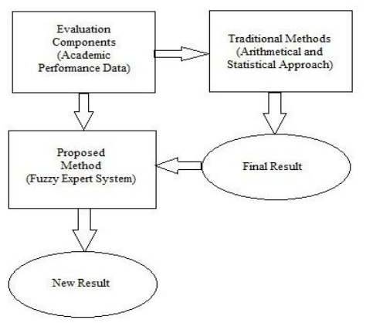

# Fuzzy rules developed in this model were based on five selected attributes, which are leadership, communication, teamwork, discipline and CGPA. Figure 2 below shows the Rubric Scoring Template that is useful as a clear guideline to the evaluators in the process of selecting the most qualified recipient for the Best Student Award. It is designed specifically to assist the evaluators in classifying the score input range for each criterion obtained by the respective candidates

# 5 Experimental Results and performance

In order to test the above model by using the fuzzy expert system and the rules defined in the present study the small data from one of the engineering college have been used. From the input data the output variable student’s subject performance is determined by Relative Grading and also by using the fuzzy model developed in the study. Last two columns of Table 4.1 show the values of student’s subject performance by Relative Grading and Fuzzy Expert System respectively.

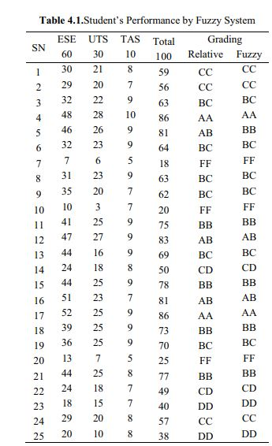

**6 Future Scope**

# In this method, we consider three parameters attendance, internal marks and external marks which are considered to evaluate students final academic performance. The fuzzy inference system has also been used to obtain Performance of Students for different input values student attendance, marks

# **7 Advantages of the system**

* his evaluation system is more accurate than conventional methods.
* Student Information uploaded once should not be lost and errors can be corrected.
* This system is very beneficial for education institutes or universities for academic performance evaluation of student efficiently

# **8.Implementation**

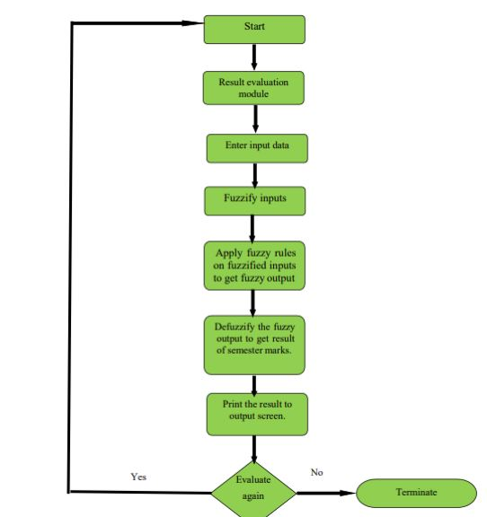

**9 Conclusion:**

Fuzzy Logic is a very good approach to evaluate uncertainties and inaccurate results. Therefore, it is morebetter than the tradition statistical method because the input can be weighted in applying the membership functions. On a critical look on the inputs of the fuzzy model, an external score helps to determine the actual students’ quality since the possibility of influencing the score will be an insignificant value.

# **10 References**

[1] F. Dernoncourt, “Introduction to Fuzzy Logic” Available at http://aisii.azc.uam.mx/mcbc/Cursos/IntCompt/Lectura15. pdf, 2013.

[2] N.S. Behbahan, S. Azari and H. Bahadori, Fuzzy Logic Applications and its Challenges, International Journal of Advanced Research in Engineering and Applied Sciences, vol. 2, no. 11, November 2013.

[3] A.Q. Ansari, “The Basics of Fuzzy Logic: A Tutorial Review”, Computereducation 88, Available at https://www.researchgate.net/publication/278031775_The_ Basics_of_Fuzzy_Logic_A_Tutorial_Review

[4] M. Akkur and D.H. Rao, “Fuzzy Logic: A Tool for Evaluation of Students’ Performance“, International Journal of Scientific and Engineering Research, vol. 9, no.10, pp. 1339-1343, October 2018.

[5] E.Sakthivel, K. S. Kannan and S. Arumugam, “Optimized Evaluation of Students’ Performance Using Fuzzy Logic”, International Journal of Scientific and Engineering Research, vol. 4, no.9, pp. 1128-1133, September 2013.

[6] A. Barlybayev, A. Sharipbay, G. Ulyukova, T. Sabyrov, B. Kuzenbayev, “Student’s performance evaluation by fuzzy logic”, Elsevier, 12th International Conference on Application of Fuzzy Systems and Soft Computing, ICAFS, pp. 98-105, Aug. 2016. doi: 10.1016/j.procs.2016.09.375.

[7] Menakshi and P. Nagar, “Application of Fuzzy Logic for Evaluation of Students Academic Performance of Computer Application Course”, International Journal for Research in Applied Science and Engineering Technology, vol. 3, no.10, pp. 260-267, October 2015.

[8] A. Kharola, S. Kunwar and G.B. Choudhury, “Students Performance Evaluation: A Fuzzy Logic Reasoning Approach”, PM World Journal, vol.4, no.9, September 2015.